**Lab Number: 1**

**Section Number: 001**

**Names: Barak Barclay**

**Assigned Date: 02/04/2016**

**Due Date: 02/11/2016**

**Introduction:**

Introduce the lab assignment and subject. What is expected to be accomplished and how you intend to accomplish each task. Discuss, if relevant, but do not show in this section, any algorithms, Boolean algebra, Karnaugh maps, and diagrams used.

(Use lines to separate sections)

**Part 1:** Include Boolean algebra and Karnaugh maps simplification (if relevant).

//Barak Barclay

//Lab1

//This module will simulate an OR gate

module LAB1_PART1 (A,F);

output F;

input A;

not G1(F,A);

endmodule

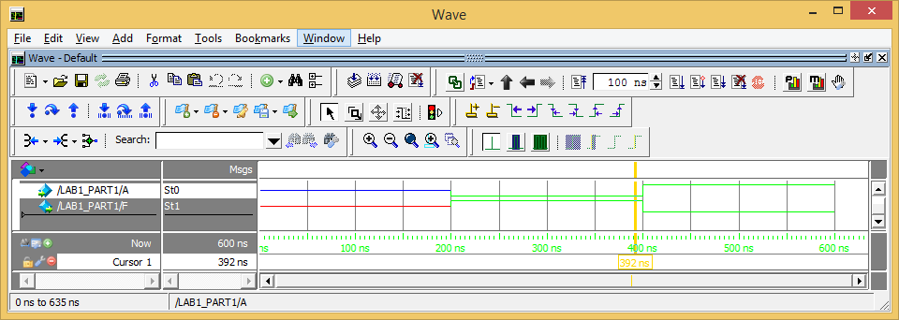

***Part 1 A.)*** Show output window first with snip tool then show code with copy/paste or with snipping.

***Part 1 B.)***

**Etc.….**

**Part 2:** Include Boolean algebra and Karnaugh maps simplification (if relevant).

***Part 2 A.)*** Show output window first with snip tool then show code with copy/paste or with snipping.

***Part 2 B.)***

**Etc.….**

**Part 3:** Include Boolean algebra and Karnaugh maps simplification (if relevant).

//Barak Barclay

//Lab1

//This module will simulate an OR gate

module LAB1_PART3 (A,B,F);

output F;

input A,B;

or G1(F,A,B);

endmodule

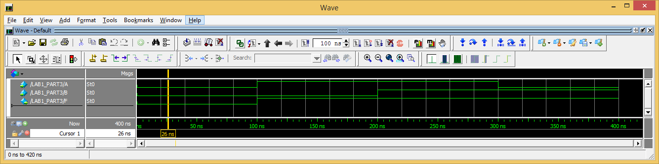

***Part 2 A.)*** Show output window first with snip tool then show code with copy/paste or with snipping.

***Part 2 B.)***

**Etc.….**

**Conclusion:**

Briefly restate what you were supposed to accomplish. Explain how each task was accomplished. Example: In Part 2 A variable xx was intended to make a square wave. As can be seen, xx makes a square wave. Handwritten labs will not be accepted!